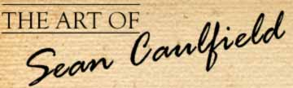 | Latest News: 07-11-2009  Yellow-Sun - 8  Today’s Mayan calendar date
Sacred Quetzalcoatl – artist: Sean Caulfield

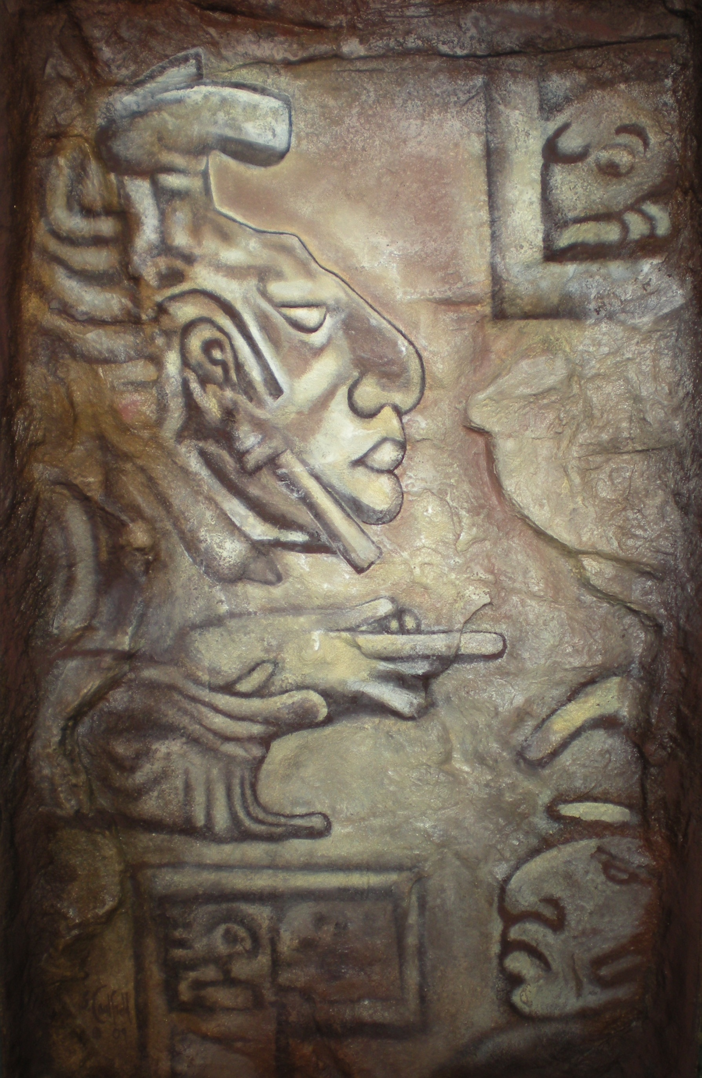

<Click here to view this painting at Rock Art Gallery website>

Quetzalcoatl - The sacred god-king Feathered Serpent depicted on a moulded rock surface by Sean Caulfield

Size is 49cm X 81cm

Art is not only the creative construct but the understanding of the purpose and its synchronicity. This painting has been guided to be shown to the universe in this time/space and it is in the understanding of its purpose that one can see the reason, thus one would have to go into the deeper understanding of the Mayan Calendar to see and feel the synchronicity.

"In Mayan prophecy, the god-king Feathered Serpent or Quetzalcoatl would return to humanity in the year 1 Reed. According to legend, as a spiritual leader he advocated the replacement of human sacrifice with flowers, songs and meditation. It was told that he erected a pillar in the city of Tula “Place of Reeds” symbolizing the World Tree as an energy conduit between heaven and earth.

The Feathered Serpent is symbolic of the unity and equality of heaven and earth energies. Its imagery portrays a serpent, usually a water serpent of the earth, ascending to the sky where it achieves knowledge, power and wisdom, symbolic of the feathers and wind.

The Feathered Serpent is the archetype of a divine human. It is the union of heaven (divine) and earth (human), the divine-human. This is the belief that each one of us has an immortal ‘spark’ (metaphorically a miniature sun) within us. We are each a Sun of God.

Each person is divine. And each person is human. And each person has an intrinsic worth/identity. This makes us all the same, but not the same. In addition, this belief includes all of nature and the earth and the heavens. Every part of creation has a ‘spark’ within itself as well as having an intrinsic quality/identity and a consciousness.

When we awaken to our true divine nature; when we recognize the two as one and the one as two; when we see past the trap of dualism that separates into opposites such as wind and water—heaven and earth; when we embrace the unifying heart wisdom that sees past the separating illusionary dualism of life to the complementary dualities of existence—a radical non-dualism; when we live the ‘I’ in the ‘We’ and the ‘We’ in the ‘I’; it is at that moment when we become ‘feathered’ (a metaphor for light) or as is more commonly known—enlightened.

Historically, there was an actual person who was called the Feathered (Precious) Serpent or the Plumed Serpent. His name was Quetzalcoatl. As a spiritual teacher and leader, Quetzalcoatl brought to the Mesoamerican people the teaching and knowledge of enlightenment through a process of symbolic death and re-birth utilizing ritualistic water immersions.

In addition, he was seen as the ‘once and future king’ destined to return when the world was at its darkest. The word Quetzalcoatl is derived from Quetzal and Coatl - literally Quetzal Serpent. A Quetzal is a brightly plumed tropical bird with brilliant bronze, green and red plumage:

Coatl is the sacred snake whose movements mirror the way that Kundalini energy moves up the spinal column awakening the wheels of light that surround each of the major body centers. When this serpentine energy reaches the crown chakra at the top of the head, we are one with the Universal. Quetzal is the sacred bird that connects Earthly power with the Heavenly realms of the universe. Together the Quetzal and the Coatl are the creatures that are closest to the earth and heaven as well as representing the sacred balance of female and male.

Quetzalcoatl was also known as the ‘Precious Twin,’ Kukulcan by the Mayas, Viracocha by the Inkas and Gukumatz by the Quiche Maya. Each was associated with Venus, the Morning Star. Once again according to Frank Waters:

Quetzalcoatl was a uniting symbol achieving union of opposites: heaven and earth, morning and evening star, matter and spirit… the transcendental meaning of this great myth is clear. It is an expression of the universal doctrine of sin and redemption, of death and resurrection, the transfiguration of man into god… this myth, in the broadest possible terms, enunciates the principle of all Creation: the incarnation of divine light, purity, and spirituality into gross matter; and then the agonizing redemption of matter by spirituality—the immortal theme of all world religions.

“…the feathered serpent has often been compared to Christ, but the feathered serpent can also be compared to Buddha because like Buddha everybody can become a feathered serpent if they reach a certain point of enlightenment. (which we call Divinehood)

Being a feathered serpent, the pluming of the serpent, is the coming of enlightenment.

But, Quetzalcoatl has a twin, his dog Xolotl. And the planet Venus is seen as being this god, Quetzalcoatl, and the planet Venus has two manifestations: it is the morning star and it is the evening star.

And as the morning start it is Quetzalcoatl, and as the evening star, it is Xolotl. As the morning star, it is darkness coming to light, reason and enlightenment; as the evening star it is the light going into dark. And this is seen as being the animal -- the animal twin that we all have with us which is very important in pre-Colombian mythology, which is our instinct.

You see, we have our reason and we have our instinct. They are both one, and the planet Venus is the same planet. It is one, but it has two manifestations as the morning star and the evening star; as Quetzalcoatl and as Xolotl.

And so when you look up into the heavens you see your inner soul reflected and the journey of your life reflected in the movements of this planet.”"

More about the energies we are now living in according to the Mayan Calendar and consciousness.

According to the Mayan Calendar, that maps time through synchronizing with natural rhythms and cycles. On the 31st of October 2009 our collective consciousness went into a 13 day cycle of Red Cane/Reed, Guiding light, a 13 day cycle to generate new energy, organize and take charge.

Creation is continually manifesting itself in the ever present now, and every 13 days allows for a new cycle of energy to unfold. This in turn holds a specific frequency that influences consciousness.

This 13 days (also known as a Trecena) starts with 1 Ben (Reed/Cane): ambitious, strong, confident, inner power, authority, crusader, champion, journeying in new directions, energy connector between heaven and earth, sharing connections with others.

Reed energy, like a pillar receiving sunlight energy, serves as the connection between heaven and earth. Thus Reed energy becomes a conduit of light energy, photosynthesis on a spiritual level, our continual link through many levels from the primordial cellular level to the higher vibrational level of multidimensional existence. This photosynthesis of energy brings out the best in us, especially our passion for a concept we believe in. We feel inclined to begin a crusade for change, and many may gravitate to those born on the Day of Reed because of their clear visions of changing the world for the better. (Barack Obama's Sacred Sun sign is Red Reed)

In Mayan prophecy, the sacred god-king Feathered Serpent or Quetzalcoatl would return to humanity in the year 1 Reed.

This conduit of light energy crests on 5th Nov - 6 Etznab (Flint), mirror or reflection, exposing our inner selves; 6th Nov - 7 Cauac (Storm), gathering energy to clear and cleanse our spirit; and 7th Nov - 8 Ahau (Sun), embodiment of light energy which encourages our inner spirit to flower.

We can utilize the energy of Reed to recognize and honor our inner power and authority. Now is the time to access this higher vibration in order to make positive changes in our individual lives and thus, the world.

On the 8th of November 2009 we enter the sixth night on the 8th level of the 9 level pyramid of creation. ( for more on this understanding please go to this website - www.calleman.com )

To understand the unfolding creation story we co-creating, we need to acknowledge that we are counting down to the completion of the divine plan where we will reach a state of universal co-creation. If we are not consciously aware of this we could miss the boat. Before our very eyes something big is unfolding, a shift in consciousness towards the light of better sacred ways, and it is from our heart that we can sense this through knowing how unbalanced this world has become, these unfolding shifts are correcting the unbalance. Our destiny is in our hands. We all have a responsibility as co-creators of this world to be more caring and sharing, more gentle and allowing. Treating life how you would treat yourself through loving yourself and others without conditions. This world is in real chaos and spinning out of control and will continue to do so until we start to live more sacredly.

It may feel like time is speeding up and it will continue to speed up causing more and more things to happen in less and less time, which will ultimately bring us to an ascension point where we will live every moment in that moment infinitely, but we will need to be in our center to do this, by being pure in every way, and one cannot think about how to do this as the heart knows how to do this through being humble and surrendering to the truth. Our mind is not who we are and will continue to challenge your true hearts desires. Follow your intuition, trust your instinct, know that your heart will pulse your blood through your feeling body through its connection to the Great Mystery that is bringing in the love and light of a new world, a world without conditions, a world of living consciously sacred and respect-filled, and ultimately purpose-filled. Know that we are living in “The Purposeful Universe” Which is also the name of Dr. Calleman’s new book he just launched on the 21st September.

I have found that through looking at the Mayan Calendar's specific day energy and seeing what is evident in my life and in the world we live in, it synchronizes to the same frequency or vibration, and this in turn makes you more in the moment and thus more conscious through connecting to a true natural timing system that has no hidden agenda.

Info is sourced from these websites below, and understood through having a passion for understanding the sacred ancient art and culture of our world and universe.

www.calleman.com
www.mayanmajix.com

Blessings, Love and Light from my heart to your heart.

In Lak’ech,
Sean Caulfiled

All welcome to join my group on facebook – “Our Sacred Universe” – follow link
http://www.facebook.com/group.php?gid=93061042757&ref=mf

For more information about the understandings of the Mayan calendar as verified by the elders alive today –
please go to www.mayanmajix.com and www.calleman.com
Any queries? Email Sean Caulfield (artist).
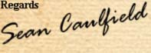  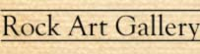  Shop No. 61-67  Blue Shed Craft Market  V&A Waterfront  Cape Town  8002  Phone No: 021 419 7055  Sean's Mobile: 072 859 5309 | 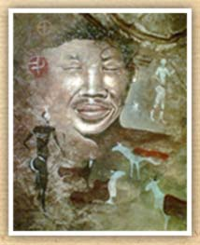
Email: info@rockartgallery.com | Website: www.rockartgallery.com

